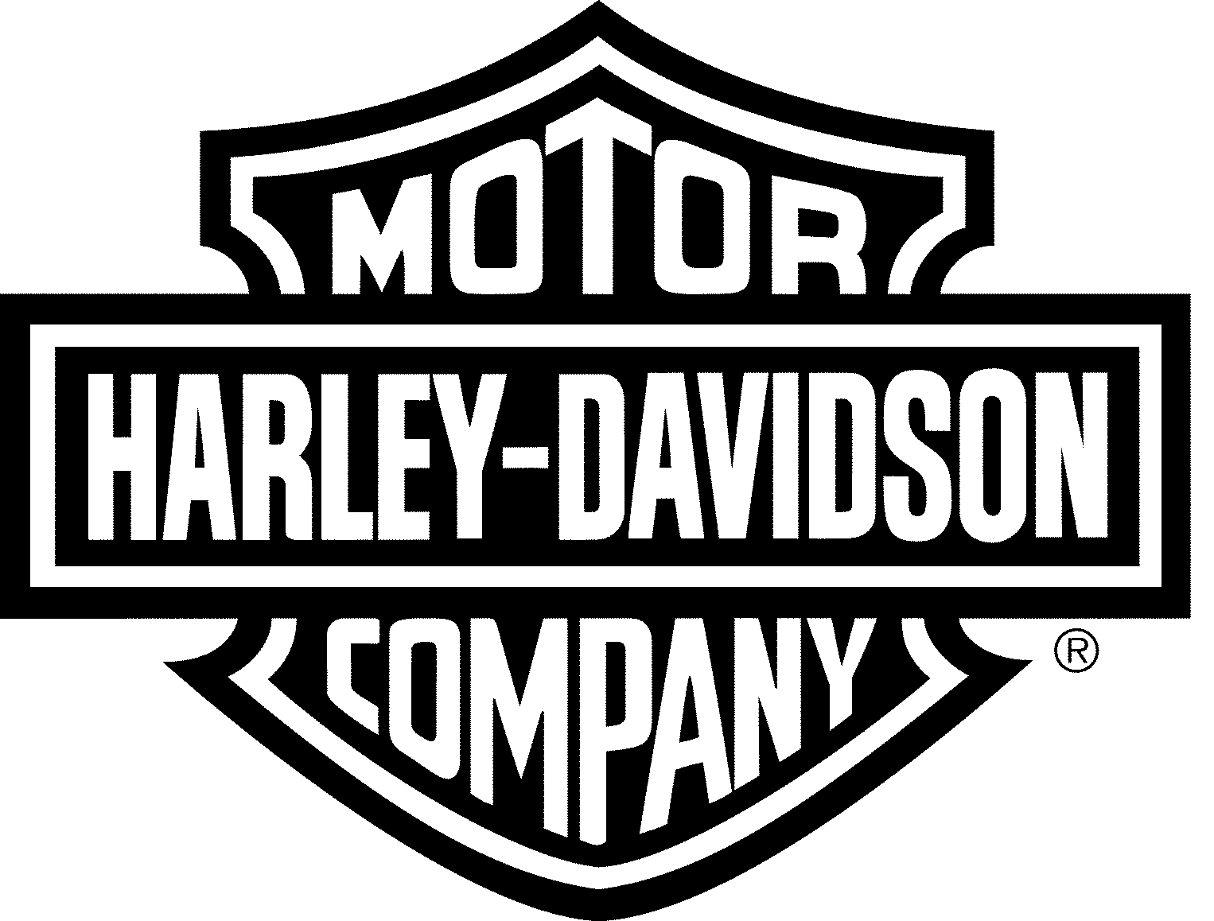
Harley-Davidson Motor Company, 3700 West Juneau Avenue, P.O. Box 653, Milwaukee, WI 53201 414/343-8246

Wednesday, January 6, 2010

Dear Elected Official:

Recently, Senator Jim Sullivan and Representative Amy Sue Vruwink introduced LRB 2138, which creates a Harley-Davidson branded automobile and truck license plate to provide supplemental revenue to the state’s current commitment to motorcycle safety. We hope you will support this initiative and help ensure a steady stream of funding is available for motorcycle safety training for both the short and long-term.

The legislation, LRB 2138, would create a Harley-Davidson automobile and truck license plate with the revenue used to promote motorcycle safety and the Share the Road program. The plate’s design would utilize Harley-Davidson’s bar and shield logo (as seen on this letterhead) on the left hand side of the plate, and the important safety message running below the plate numbers. The safety message would read: Share the Road.

Similar to the Green Bay Packer and Milwaukee Brewer license plate, this plate’s revenues would go to a specific purpose. In this case, the revenue would be transferred to a new account for motorcycle, moped, and motor bicycle safety in the Department of Transportation. Eligible uses of the funds are as follows:
*Making grants for providing motorcycle riding courses;
*Evaluation of basic rider courses, which includes quality assurance audits;
*Conducting public workshops, including attendance at rallies;
*For programs related to motorcycle safety and training.

Motorcycling plays a major role in our state’s economy. To that end, it is important to ensure that all users of our roadways are seen and aware of their surroundings and others on the road, such as motorcycles. We want to ensure that everyone has a positive experience when traveling on the roadways in Wisconsin.

Again, please consider supporting LRB 2138. If you would like to co-sponsor this legislation, please contact either Senator Sullivan or Representative Vruwink’s office by Friday, January 8th.

Ride Free,

Michael Richards
Manager, Government Affairs

